THREE-YEAR PREDICTORS OF SURVIVAL AMONG HYPERTENSIVE PATIENTS ATTENDING OUTPATIENT CLINICS WITHIN RURAL DISTRICTS OF IRINGA REGION FROM
2020-2023.

Katunzi Mutalemwa, (RN,BScN)

Master of Science in Cardiovascular Nursing Dissertation
Muhimbili University of Health and Allied Sciences"
October, 2024

MUHIMBILI UNIVERSITY OF HEALTH AND ALLIED SCIENCES
SCHOOL OF NURSING
DEPARTMENT OF CLINICAL NURSING



PREDICTORS OF SURVIVAL AMONG HYPERTENSIVE PATIENTS ATTENDING OUTPATIENT CLINICS WITHIN RURAL DISTRICTS OF IRINGA REGION FROM 2020-2023.

By
Katunzi Mutalemwa
HD/MUH/T.501/2022

"A Dissertation Submitted in Partial Fulfillment of the Requirements for the Master of Science in Cardiovascular Nursing of the Muhimbili University of Health and Allied Sciences"

October, 2024

CERTIFICATION
The undersigned certifies that they have read and hereby recommends for acceptance by the University of Muhimbili Health and Allied Sciences a dissertation entitled "Predictors of survival among hypertensive patients attending outpatient clinics within rural districts of Iringa region" in partial fulfilment of the requirement for the degree of Master of Science in Cardiovascular Nursing

______________________
Dr. Khadija I. Yahya-Malima (BScN,MPhil, PhD)

Supervisor

Date………………….

______________________
Ms. Emelia T. Mwakanyanga ( BScN, MScN)
Co-supervisor

Date………………….

DECLARATION AND COPYRIGHT

I, Katunzi Mutalemwa, declare that this dissertation is my own original work, and that has not been submitted and will not be presented to any university for a similar or any other degree award.

Signature: ________________________ Date: _______/_______/________

Statement of Copyright
This dissertation contains copyrighted content protected by the Berne Convention, the Copyright Act of 1999, and other international and national intellectual property laws. It may not be reproduced in whole or in part, except for short extracts in fair dealing, for research or private study, critical scholarly review, or 138 discourse with an acknowledgement, without the written permission of the Directorate of Postgraduate Studies, on behalf of both the author and Muhimbili University of Health and Allied Sciences.

ACKNOWLEDGEMENT
First and foremost, I would like to thank the Almighty God for his undeserved grace towards having this research work fruitfully.
Secondly, I sincerely thank my supervisors, Dr. Khadija I. Yahya-Malima and Ms. Emelia T. Mwakanyanga, for their guidance throughout the tenure of this study. Likewise, the teaching staff at the School of Nursing deserve a mention for their pivotal role in accomplishing this research work. I thank the Dean of the School of Nursing, Dr. Dickson Mkoka, for his unwavering moral support and heartfelt encouragement over the study period.
Special gratitude goes to the Doctors with Africa CUAMM and the Iringa District Council for their permission to use the database of the NCDs project to carry out this study. Furthermore, the following are worth mentioning, for this research project would not have come to life without their professional starring role in many aspects: Mario Saugo, Monir Mazaheri, Paolo Belardi, Rosemary Eustace, Tumaini Nyamuhanga, and Francesca Tognon.
I also extend exceptional thanks to my lovely parents, Mr. and Mrs. Mutalemwa, whose love and unceasing care fueled my journey towards making this a living dream. Your love, care, instructions and directions have always been a cornerstone to my adventure towards exploring and realizing the talents and dreams endowed in me. A hundred thanks, My brothers Dastan, Denis, Avitus, Alimachius and sister Avitha, you are all appreciated for the genuine love and unconditional support you gave me in making this academic treasure.
A list of friends is also to go without missing on this appreciation platform for their contributions to Noemi, Giuseppe, Davide, Didas,Agata, Elisabetta, Valentino, Giulia, Giacomo, Silvia, Martina, Lucia, Sara, Pietro, Victoria, Benedetta, Frederico, Giustina, Federica, Peter, Max, and Åsa.
Lastly, classmates and teachers throughout my alma mater also hold special recognition from me: Rubya B, Humura, Tarakea, Swedish Red Cross University, KCMUCo, and Muhimbili University of Health and Allied Sciences.

DEDICATION

For My lovely Mom Tryphina Edward Rugaiganisa

ABSTRACT
Background: Hypertension in Tanzania accounts for 25.9% of cardiovascular disease risk factors despite the availability of specialized clinics, even in rural areas, to manage the disease and associated complications. Thus, evaluating outcomes of clinical care provided for a rural hypertensive cohort may give insight into how well clinical care promotes survival with hypertension without debilitating effects.
Objective: To describe the three-year survival outcomes of hypertensive patients attending a Non-communicable Disease clinic in rural Iringa from 2020-2023.
Methodology: This study analyzed a registry-based retrospective cohort identifying clinical outcomes of diagnosed adult hypertensive patients within rural health facilities in the Iringa district council. The study population was all hypertensive patients on follow-up visits in 9 health centres and district hospitals in the Iringa district council. Using epi-info, the data was analyzed, survival predictors were estimated using the Kaplan-Meier estimator, and the Log-rank test was used for comparisons. The Cox proportional hazards model was used to identify independent effects of the predictors of survival.
Results: Between 2020 and 2023, the clinics enrolled 1194 participants (76% (n=910) were women) for hypertensive-related disorders. The mean age of patients was 61±5.4 SD years (IQR 18 -89 years); of these, 83.6% (n=998) were hypertensive-only patients, and 16.4% (n=196) were both diabetic-hypertensive. Out of 718 returning patients, 31.3 % (n=225): (95%CI: 28 - 35) patients reached optimum BP in the first six months, and 11.5% (n=21) (95% CI: 17 – 36) reached BP at thirty-six months respectively. Significant predictors of survival with optimum blood pressure control were living closer to the district hospital, those who had a hypertensive crisis at the initial assessment, and having fewer follow-up visits.
Conclusion: The findings underscore the need to provide primary health care services closer to the community residential areas within rural settings. In this community, the patients with a severe hypertensive crisis were more likely responsive to treatment compared to others, and compliance to clinical attendance decreased with time, irrespective of the availability of care.
TABLE OF CONTENTS
CERTIFICATION i
DECLARATION AND COPYRIGHT ii
ACKNOWLEDGEMENT iii
DEDICATION iv
ABSTRACT v
LIST OF TABLES ix
LIST OF FIGURES x
LIST OF ABBREVIATIONS xi
DEFINITION OF TERMS xii
CHAPTER ONE 1
1.0 INTRODUCTION 1
1.1 Background 1
1.2 Problem statement 3
1.3 Conceptual framework 4
1.4 Rationale of the study 5
1.5 Research question and objectives 6
1.5.1 Main research question 6
1.5.2 Specific Research Questions 6
1.5.3 Broad Objective 6
1.5.4 Specific objectives 6
CHAPTER TWO 7
2.0 LITERATURE REVIEW 7
2.1 Prevalence and associated complication morbidity due to hypertension and its complications. 7
2.2 Available evidence on the management of hypertension and survival 9
2.3 Challenges and Opportunities to Management Hypertension 11
CHAPTER THREE 13
3.0 RESEARCH METHODOLOGY 13
3.1 Study design 13
3.2 Study area 13
3.3 Study population 13
3.4 The inclusion and exclusion criteria 13
3.5 Study exposures, predictors and outcomes 14
3.6 . Sample size and selection 14
3.6.1 Sample size 14
3.7 Study variables 14
3.7.1 Dependent variable 14
3.7.2 Independent variables 14
3.8 Data collection and analysis. 14
3.9 Validity and Reliability 15
3.10 Ethical issues and ethical consideration 16
CHAPTER FOUR 17
4.0 RESULTS 17
4.1 Social Demographic Characteristics 17
4.2 The baseline characteristics of hypertensive patients attending NCDs clinic in rural Iringa 18
4.3 The rate of time to event of reaching optimal blood pressure of 140/90 mmHg among hypertensive patients enrolled in NCDs clinic in rural Iringa. 21
4.4 Factors that influence time to event of reaching optimal blood pressure of 140/90 mmHg among hypertensive patients enrolled in NCDs project in rural Iringa 26
CHAPTER FIVE 29
5.0 DISCUSSION 29
5.1 Discussion 29
5.1.1 Baseline characteristics of hypertensive patients attending NCDs clinic in rural Iringa. 29
5.1.2 The rate of time to reach optimal blood pressure among hypertensive patients attending NCDs clinic in rural Iringa. 30
5.1.3 Factors that influence reaching optimal blood pressure among hypertensive patients attending NCDs clinic in rural Iringa. 31
5.1.4 Cardiovascular Nursing Implications. 32
5.2 Strengths and limitation of the study 32
5.2.1 Strengths 32
5.2.2 Limitation 32
CHAPTER SIX 34
6.0 CONCLUSION AND RECOMMENDATIONS 34
6.1 Conclusion 34
6.2 Recommendations 35
7.0 REFERENCES 36
8.0 APPENDICES 42
8.1 APPENDIX I: DATA COLLECTION TOOLS 42
8.2 APPENDIX II: ETHICAL CLEARANCE APPROVAL 46
8.3 APPENDIX III: INTRODUCTION LETTER 48
8.4 APPENDIX IV: PERMISSION LETTER 49
8.5 APPENDIX V: PLAGIARISM CERTIFICATES 52

LIST OF TABLES
Table 1: Social Demographic characteristics of patients enrolled in NCDs project 17
Table 2: Clinical Characteristics of patients enrolled in NCDs project 18
Table 3: Follow up visits of hypertensive patients enrolled in NCDs project 19
Table 4: The baseline and clinical profile of patients with health insurance 20
Table 5: Kaplan–Meier function for reaching Blood Pressure target among hypertensive patients enrolled in NCDs project. 21
Table 6: The log rank test for time to reach blood pressure target i.e BP 140/90 mmHg among hypertensive patients enrolled in NCDs project. 22
Table 7: Cox-regression multivariate analysis for time to reach blood pressure target i.e BP 140/90 mmHg 27

LIST OF FIGURES
Figure 1: Modified chronic diseases conceptual framework from the WHO's determinants of health and their impacts. 5
Figure 2: Kaplan-Meier graph of survival with target blood pressure 22
Figure 3: Kaplan-Meier graph of survival estimate with target blood pressure based on health insurance 24
Figure 4: Kaplan-Meier graph of survival estimate with target blood pressure-based distance from District Hospital 24
Figure 5: Kaplan-Meier graph of survival estimate with target blood pressure-based number of follow up visits 25
Figure 6: Kaplan-Meier graph of survival estimate with target blood pressure-based Blood pressure level at initial assessment 25
Figure 7: Kaplan-Meier graph of survival estimate with target blood pressure based on complications 26

LIST OF ABBREVIATIONS
BMI | Body Mass Index
BP | Blood pressure
CHD | Congestive Heart Disease
CDC | Centre for Disease Prevention and control
CKD | Chronic Kidney Disease
CUAMM | Collegio Universitario Aspiranti e Medici Misssionari
CVDs  DED | Cardiovascular Diseases  District Executive Director
DASH | Dietary Approaches to Stop Hypertension
ESRD | End Stage Renal Disease
FBG | Fasting Blood Glucose
H.I.C.s | High Income Countries
HR | Hazard Ratio
HTN | Hypertension
IHD | Ischemic Heart Disease
LB | Low boundary
UP | Upper boundary
L.I.C.s | Low Income Countries
MUHAS | Muhimbili University of Health and Allied Sciences
NCDs | Non-Communicable Diseases
NHIF | National Health Insurance Fund
RBG | Random Blood Glucose
SD | Standard Deviation
WHO | World Health Organization

DEFINITION OF TERMS
Hypertension is when blood pressure within blood vessels is above 140/90 mmHg, which can be severe if not treated (1).

A predictor is any relevant event that can enable us to foresee what will happen in the future. (2)

Survival Analysis is a collection of statistical procedures for data analysis where the outcome variable of interest is time until an event occurs (5).
Optimal blood pressure refers to blood pressure less or equal 140/90 mmHg (1)
Censoring refers to a state in which information concerning an individual's survival time is incomplete. This usually happens when an event of interest such as death, failure, relapse, etc. is not detected in certain participants during the study period. Censoring is crucial in survival analysis, and it is vital to address it appropriately to avoid bias in the study. (3)

Survival time analysis: For this study, a group of statistical methods that evaluate the time it takes for a diagnosed hypertensive patient enrolled in an NCD within Iringa Health facility for treatment of hypertension based on the National guidelines of Hypertension management, to a time when that patient attains the optimum healthy blood pressure reading. The time between the start of treatment until the optimum BP is reached was analyzed as well as factors that affected the time for attaining the optimal blood pressure. There are situations where not all patients were not accounted for loss of follow up or they move, so their information was censored and Kaplan meir was used to estimate how long it takes to reach optimum PB and we looked into how many patients attained the optimal blood pressure that at the first six months of treatment.

Survival rate refers to a population still alive at successive times for as long as information is available. It can also be termed the persistence of freedom from disease, complication, or some other endpoint (3). The proportion of survivors in a group, such as patients being studied and monitored throughout time or the proportion of people living at the start of a time interval who live to the end of the interval (4).
An event refers to the outcome of interest in the study, which is having optimal BP on the last visit.

CHAPTER ONE

INTRODUCTION

Background
Hypertension (HTN) is one of the diseases of high burden that affects more than a billion adults aged between 30 and 79 years worldwide, while about two-thirds are from low-income countries. It is the primary cause of premature death worldwide, with approximately one to five hypertensive adults under control. Around 46% of adults with hypertension in developing countries are unaware that they have the condition, while 42% of adults with hypertension are diagnosed and treated. The global target for Non-Communicable Diseases [NCDs] is to reduce the prevalence of hypertension by 33% by 2030. Uncontrolled hypertension is the leading cause of cardiovascular complications such as heart failure, stroke, myocardial infarction and kidney diseases, and it stands as the significant risk factor for cardiovascular morbidity and mortality (1,6,7).
Despite numerous control measures undertaken due to evidence from research, such as emphasis on healthy diets, exercises, weight loss, and compliance to medical treatment, Sub-Saharan Africa stands as the significant leading area with a high prevalence of hypertension. The World Health Organization estimates that the prevalence of hypertension is highest in the African region, with about 46% of adults aged 25 years and older being hypertensive compared to 35% in the Americas and other developed countries and 40% in other parts of the world. In Africa, the estimated number of people with hypertension has increased by 70% from 1990 to 2000, while 41% has increased from the year 2000 and it is estimated to be higher by 2030 (1,8).
Hypertension is widespread in Africa, with Tanzania and Kenya experiencing the highest prevalence. In Tanzania, Hypertension accounts for 25.9%, and it is counted as the highest risk factor for cardiovascular diseases (CVDs) in assimilation to other risk factors, including diabetes, elevated cholesterol, lifestyle conditions like overweight and obesity and cigarette smoking by 9.1%, 26%, 26% and 15.9% respectively. Many patients suffering from hypertension are not aware of the condition since it shows no symptoms until complications arise, such as stroke, heart failure and kidney failure (9–11). Lifestyle modification and good nutritional habits are associated with lifetime blood pressure control and lowering the risk for CVDs. However, uncontrolled hypertension is related to poor self-care practices among hypertensive patients. The poor self-care practices include non-adherence to medications, high salt intake, physical inactivity, smoking and tobacco usage, excessive alcohol intake and poor healthy diet. Furthermore, predictors for self-care practices among hypertensive patients include female sex, level of education, marital status, young age, normal weight, level of education, and hypertension knowledge are positively associated with blood pressure control and survival among hypertensive patients (12,13). However, when it comes to health-seeking behaviour, African men are always reluctant on health services due to masculinity related to cultural norms such as resistance to seek care when sick and low knowledge of health-related issues (14).

This study aimed to determine the predictors of survival among hypertensive patients attending NCD clinics within rural health facilities in the Iringa region.

Problem statement
Researchers have proven over time that hypertension is one of the most modifiable diseases. However, it continues to be among the second leading causes of death in Tanzania, with about 46% of adults aged 25 years and older. The Ministry of Health of Tanzania reports hypertension to account for 25.9% of adult morbidity. It is the highest risk factor for cardiovascular diseases (CVDs) and can be averted once the diagnosis is confirmed, given compliance to treatment and consistent healthier lifestyle adoption. Despite the available evidence, behaviour modification to control hypertension is still a hard-to-reach target, even among the regions outside the major cities like Iringa. Thus, it is not clear what causes the worsening trend in hypertension burden, given standardized clinical care even within rural areas. Evaluating outcomes of clinical care provided for a hypertensive cohort may give insight into how well clinical care promotes survival with hypertension without debilitating effects.
The Iringa District Council has enrolled hypertensive patients among outpatient attendees for non-communicable diseases since 2019. Among 1902 patients, 72% (n=1369) are hypertensive, 15% are diabetic (n=286) and 13% (n=247) patients with both diabetes and hypertension. The establishment of the cohort has the potential to avert CVDs and other complication events and save lives by carefully monitoring diagnosed patients over time. To date, the Iringa cohort records show that 29% (n=552) of the enrolled male population had developed complications such as stroke and chronic kidney disease, and 40% (n=547) of hypertensive patients were not on treatment on their first visit by June 2023. It indicates that lifestyle changes have also affected the rural population's health to be similar to the NCD profiles of the urban dwellers. Such an epidemiological shift needs to be corrected to avert disabilities, prevent death and save lives based on the clinical management of an identified cohort. Thus, this study examined the survival effect of early clinical exposure to hypertensive patient management through cohort enrollment.

Conceptual framework
A conceptual framework always deals with abstractions gathered by their relevance to a common theme. It usually presents the phenomenon of interest and reflects the assumptions of the relevant theme(15). This study used the modified WHO chronic diseases conceptual framework from the WHO determinants of health and their impacts. The model identifies the relationship between various factors in surviveal for chronic diseases. Some factors such as income, education, occupation, gender, and race/ethnicity have a positive contribution to survival among chronic NCDs patients. These socioeconomic positions shape specific health status determinants, which reflect people's place within social hierarchies. Also, individuals experience different exposure and vulnerability to health-compromising conditions based on their social status (16). Social determinants are factors that define the health opportunities within social groups. They underline power, prestige, and access to health resources, showing individual social and economic position. It includes income, gender, educational level, and marital status, which directly affect health (16). The health system as the social determinant of health is highlighted by the question of access, which includes variations in exposure and vulnerability and directly addresses disparities in exposure and vulnerability by enhancing equal access to care and encouraging intersectoral action to enhance health status. However, its operation faces many challenges due to economic demand and health services burden, especially for chronic NCDs (16). Lifestyle factors such as smoking, diet, alcohol consumption, and physical exercise are undoubtedly essential determinants of health as well as determinants of health inequalities for NCDs due to their uneven distribution between socioeconomic positions (16).

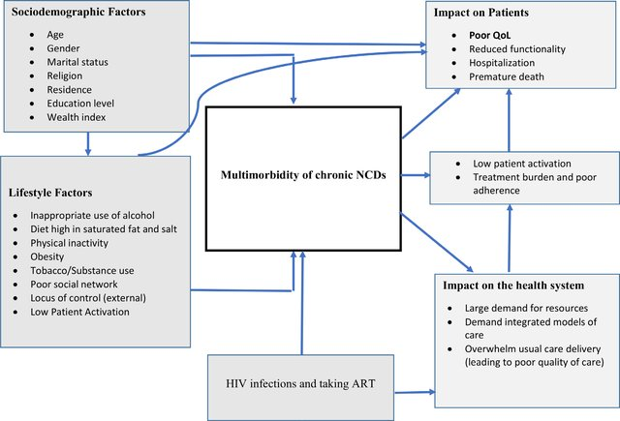
Survival for NCDs
Hypertension and treatment
Figure 1: Modified chronic diseases conceptual framework from the WHO's determinants of health and their impacts.

Rationale of the study
Despite efforts to update guidelines on the management of hypertension and the development and use of new and better hypertensive drugs, the healthcare system still experiences excess mortality due to cardiovascular-related complications of hypertension, and the continual challenge of behaviour modification for optimum control of blood pressure underscores the need to evaluate outcomes of care and identify gaps for improvement. Assessing clinical outcomes of hypertensive patients managed under routine care is essential to gauge the effect of clinical management and determine outcomes of patient-related behavioural and lifestyle changes since diagnosis, hence, this study. Moreover, it is not certain what are the predictors for survival with hypertension in rural areas as the related physical activities in the areas are significantly different from those of urban areas thus, identifying predictors of better health outcomes or identifying additional risks may be of importance to guide interventions.

Research question and objectives

Main research question
What are the predictors of survival with hypertension among hypertensive patients in rural Iringa from 2020-2023?

Specific Research Questions
- What are the baseline characteristics of hypertensive patients attending the Non-Communicable Disease clinics in rural Iringa from 2020-2023?
- What is the rate of time to event of reaching optimal BP (140/90 mmHg) among diagnosed patients from diagnosis in rural Iringa from 2020-2023?
- What factors that influence time to event of reaching optimal BP among hypertensive patients attending Non-Communicable Disease clinics in rural Iringa from 2020-2023?

Broad Objective
To describe predictors of survival with hypertension among hypertensive patients attending Non-Communicable Disease clinics in rural Iringa from 2020-2023.

Specific objectives
- To describe baseline characteristics of hypertensive patients attending the Non-Communicable Disease clinics in rural Iringa from 2020-2023
- To determine the rate of time to the event of reaching optimal BP (140/90 mmHg) among patients with hypertension in the cohort during the three years of follow-up
- To determine factors that influence the time needed to reach optimal BP (140/90 mmHg) among patients with diagnosed hypertension

CHAPTER TWO

LITERATURE REVIEW

Introduction
This literature review aims to synthesize current studies on predictors of survival with hypertension among hypertensive patients, focusing on demographic, clinical, and behavioral factors. Nevertheless, some studies have investigated the predictors of survival in patients with hypertension, which include a broad range of factors, including demographic variables, comorbidities, lifestyle behaviors, and the effectiveness of treatment regimens. Analyzing the existing knowledge on the predictors of survival with hypertension will help to highlight gaps in the literature and suggest avenues for future research that could improve patient outcomes and inform clinical practice.

Prevalence and associated complication morbidity due to hypertension and its complications.
Hypertension is the major risk factor for cardiovascular diseases (CVDs) and premature deaths. It accounts for 1.28 billion adults aged between 30 and 70 years worldwide, mostly from low- and middle-income countries. However, 46% of hypertensive patients are unaware of their disease, while 42% are diagnosed and treated. There is a high prevalence of hypertension in the African region, 27%, compared to 18% in the American region. The number of patients has been primarily observed in low- and middle-income countries, rising from 594 million in 1975 to 1.13 billion in 2015. Several factors are associated with an increase in hypertension in both low and middle countries, including age, exposure to unhealthy lifestyles and physical inactivity. Nonetheless, over the past two decades, high-income countries (HICs) have experienced a decrease in hypertensive prevalence compared to low-income countries (LICs), which have faced a significant rise. These disparities have assumed a high burden of Hypertension and CVD in their healthcare system (1,17,18).
According to the Global Burden of Disease research, 3.5 billion persons worldwide had raised systolic blood pressure at least 110-115 mmHg in 2015 (17). This range links to a higher risk of ischemic diseases, stroke, and kidney disease. In 2015, 19.2% of all global deaths were associated with systolic blood pressure above 110-115mmHg, while 14.0% were linked to systolic blood pressure above 140mmHg. Among these deaths, 54.5%,50.0% and 58.3% were due to Ischemic Heart Diseases (IHD), stroke and hemorrhagic stroke deaths, respectively. Likewise, uncontrolled elevated blood pressure is a substantial cause of Chronic Kidney Disease (CKD) and End Stage Renal Disease (ESRD). Uncontrolled hypertension has a positive contribution to various complications such as stroke, heart failure and IHD. in line with other complications. Similarly, in Cameroon, elevated blood pressure was found as the most common cause of CKD by 78.8%, 69.7% retinopathy, 48.5% left ventricular hypertrophy, and 27.3% stroke (17–19).
The highest prevalence of hypertension is among men at 39% in Eastern Europe and Central Asia, and the lowest prevalence in South Asia at 26.4%. In comparison, women had the lowest prevalence of HICs, 25.3%, compared to 36.3 % in sub-Saharan Africa. Comparably, males had a higher prevalence of hypertension by 41.4% over 37.7% of women. These regional differences were attributed to environmental and social factors such as availability of medications, accessibility of health services and hypertensive risk factors. Poor control of blood pressure among female sex workers in comparison to males, with associated comorbidities such as heart failure and myocardial infarction. Furthermore, residents of rural areas were found to have a high prevalence compared to residents of urban in HICs, while it was vice versa in LICs, including sub-Saharan Africa(17,19).
In sub–Saharan Africa, the age-adjusted prevalence of hypertension was 25.9%. In comparison, 50% of participants were aware of their raised blood pressure, and the level of awareness varied based on age group. Furthermore, the crude prevalence of prehypertension was 29.8%, while the age-adjusted prevalence of prehypertension was 21.0%. In seven communities in East and West Africa, a quarter of participants were found to have hypertension while about 40% were unaware and half were on regular treatments with controlled blood pressure. In this regard, almost half of the hypertensive patients were not on regular treatment and some were even not aware of their disease situation. Moreover, hypertension was higher among participants aged above 50 years and those with a Body Mass Index(BMI) between 25 to 29.9 kg/m² while level of education and tobacco usage were among the drivers for hypertension. (9–11,20).
There is a growing prevalence of hypertension in both rural and urban populations of Tanzania. Between 1990-2000 the prevalence of hypertension was 3-27% in rural areas and 5-39% in urban areas. Surprisingly, prevalence increased by 13-70% in rural areas and 12-65% in urban areas between 2000 and 2016. The population-based study done in Tanzania rural areas found the estimated prevalence of hypertension was 19.9% while the prehypertension estimated prevalence was 38.0% in the ratio of 15.6% for stage I hypertension and 4.3% for stage II hypertension. However, there was a significant increase in blood pressure with age in females compared to males (21–23). Furthermore, hypertension leads to 34% of NCD deaths and all deaths in Tanzania, and it stands as the most common cause of heart failure and stroke complications. Conversely, a community study done in north Tanzania found that older males with excessive consumption of alcohol living in urban areas were more likely to be hypertensive compared to females. Likewise, the prevalence of hypertension in north Tanzania was 28% (21–23).
In 2019, a project dedicated to caring for patients with hypertension and Diabetes was established in the Iringa rural district. It involves routine follow-up visits and management of diseases, such as adherence to lifestyle modifications among ten health centers found within the district. With four years of existence, the project has enrolled 1800 patients, and 50% are on follow-up visits with 1376 hypertensive patients. The project reports on most patients' challenges in complying with lifestyle modification and medication adherence. Thus, analysis of clinical outcomes may give insight into timely interventions to prevent cardiovascular complications in the remaining cohort, as some have already succumbed. This study will determine the status quo of the cohort and provide gaps to improve care and successful interventions to be maintained (24).

Available evidence on the management of hypertension and survival
Hypertension requires lifestyle modifications such as low salt intake and dietary fat. Most hypertensive patients face difficulties adopting healthy nutritional habits for various reasons, such as food availability, their work, and their economic status. Diet and nutrition have been extensively investigated as risk factors for major cardiovascular diseases like coronary heart disease (CHD) and stroke. Similarly, it is linked with other cardiovascular risk factors like diabetes, high blood pressure and obesity. The recommended nutritional food includes low-density lipoproteins, fatty acids, minerals, fruits and vegetation (25).
In 2013, WHO designed a healthy diet called Dietary Approaches to Stop Hypertension (DASH), which consists of foods that are healthy for hypertensive patients. The DASH diet mainly consists of fruits, vegetables and low-fat dairy products and includes whole grains, poultry, fish and nuts while reducing the amount of red meat, sweets and sugar-containing beverages. However, the adoption of health diets faces challenges such as food availability, economic struggles, nutritional knowledge and perception of the disease (1).
In Canada, the odds of hypertension were 60% times higher among consumers of processed food compared to non-consumers of unprocessed food. The high incidence of consumption of processed food was reported in urban areas compared to rural areas. However, the self-reporting prevalence of hypertension, diabetes, obesity and heart diseases among consumers of processed food were 20%, 7%, 26% and 5% respectively. Furthermore, consumption of ultra-processed food showed variation by age. The strongest association was among adults aged 19 to 50, followed by older adults aged 65 or older, with a significantly elevated effect amongst those aged 51–64 ​(26,27).
In Zimbabwe, most hypertensive patients add salt to meals cooked with salt when eating. Like, hypertensive patients who were aware of the disease were 27% more likely to use processed food and 82 less likely to add salt to their food (28). Conversely, those who were aware were more protective against additional salt and excessive consumption of vegetative oil. Culturally, many households in Zimbabwe prepare meals with gravy thickeners and flavour cubes that are too salty. The practice contributes to serious cardiovascular complications such as strokes, kidney failure, and heart failure, especially in men compared to women. Similarly, in Khartoum, about 84.8% of hypertensive patients were minimizing salt intake in their diet, 96.4% did not smoke, and all respondents reported no alcohol consumption ​. Additionally, 52 % of patients with hypertension were engaged in the recommended low salt diet in Ethiopia, while 34 hypertensive patients followed the recommended directives on avoiding alcohol consumption (28–30).
In Tanzania, the studies conducted in the 1980s showed that the prevalence of hypertension was around 3% to 7% in rural areas and 10% in Dar es Salaam. However, the incidence was 48.9 % among executives due to advanced life practices such as high dietary salt, low dietary potassium, alcohol consumption, obesity, mental stress, and maternal undernutrition in pregnancy (31).
In response to the increased burden on NCDs in Tanzania, the Ministry of Health prepared various guidelines for attending NCDs, including Hypertension. In 2008, the Ministry of Health and Social Welfare developed the national strategic plan for NCDs. However, the guideline was impractical in monitoring disease control, especially hypertension. Later, in 2016, a new strategic plan and action plan for managing NCDs was developed, which has played a unique role in the primary and secondary prevention of hypertension and reduction of morbidity and mortality in NCDs in Tanzania. Furthermore, Tanzania has been benefiting from the endorsement from WHO for NCDs control and treatment including the WHO Package of Essential Non-communicable (PEN) disease currently operating in Kondoa and Karatu and WHO STEPwise where the country can collect, analyze and disseminate data regarding NCDs (31,32).

Challenges and Opportunities to Management Hypertension
The adherence to medication and self-care control among hypertensive patients was associated with various predictors such as female sex, normal weight, hypertension knowledge, self-efficacy, younger age, social support female sex, normal weight, time from first diagnosis and marital status. The participants with good social support were 2.81 more likely to adhere to blood pressure control. At the same time, females were 3.63 more likely non-smoking compared to males and those with adequate knowledge of hypertension were 2.58 more likely to adhere compared to those with less knowledge. Around 13.76% of hypertensive patients did not take medication 19.87% had reasonable blood pressure control, while 13.74 had poor control. Similarly, 66.39% of hypertensive patients did not check their blood pressure over the past two years. The treatment adherence was found to be related to age since, as it age advances, the complexity of treatment with more than one drug increases. It was shown that 29% of elderly hypertensive patients above 65 years were on three to four drugs and that 69% had controlled blood pressure while 48% had uncontrolled blood pressure. Furthermore, the female sex was found to have poor control of blood pressure at an advanced age given gender-specific predispositions (12,19).
In India, 47% of known hypertensive patients were not on medication, given that challenges of accessing the drugs and transport costs were shared as the significant challenges by the majority, and they would . Most would prefer accessing their services in non-public hospital settings, and females showed good health-seeking behaviour compared to males. Similarly, In Uganda, health-seeking behaviour among hypertensive patients was found to be associated with availability of medicine, burden of acute care at facilities, patient waiting time and traditional medicine (33,34).
In northern Tanzania, 12% of patients with elevated blood pressure reported that they utilized traditional medicines as a means to cure disease and alleviate symptoms. Similarly, structural issues in health care facilities, such as long waiting times, understaffing, drug costs, and point of care communication between providers and patients, were listed among the causes of poor blood pressure control. Furthermore, intolerable side effects of drugs, improper counselling, responsibilities at home and work as well as a struggle burnout staff were mentioned (21,35).

CHAPTER THREE

RESEARCH METHODOLOGY

Study design
The study design was retrospective cohort design. Given the increasing burden, the retrospective cohort design was appropriate to assist in promptly measuring clinical outcomes of hypertension control within rural areas. Exposure and outbreaks of hypertension are becoming common, and we need to be able to determine outcomes of care to allow for the improvement of health in the population. It is also imperative to identify early-stage associations that worsen the diseases. Thus, this was an opportunity given the registry-based retrospective cohort study in Iringa.

Study area
The study was conducted in the Iringa region. It has three districts: Iringa, Kilolo, and Mufindi. The region has a total population of 1,192,728 people (36). The study was based on the Iringa District Council, which has a total population of 322704. Most are peasants, some in business, and few have official employment. The ongoing collaborative project dedicated to caring for patients with Hypertension and Diabetes between an organization of Doctors in Africa and district authorities provided an ideal opportunity to conduct this study. The project offers care in 9 health centres and a district hospital within the Iringa district council.

Study population
The study population was all hypertensive patients on follow-up visits in 9 health centres and district hospital in the Iringa district council.

The inclusion and exclusion criteria

Inclusion criteria
The data from all known hypertensive adult (≥ 18 years) patients on treatment enrolled in the NCDs project from January 2020 to December 2023 with at least six months of laboratory investigations was included in the database,

Exclusion criteria
All hypertensive patients with incomplete information were excluded. Patients that until December 2023 have a) not yet experienced the relevant outcome of optimal blood pressure, b) patients lost to follow-up during the study period, (c) those patients with different events who made further follow-up impossible, were censored.

Study exposures, predictors and outcomes
The primary endpoint of this study was time from enrollment to survival at optimal blood pressure control. The primary exposure was hypertension, as these were the enrollees in the cohort of the NCD clinic. The BP measurements, height, and weight were extracted from the database. A checklist of included variables is appended in this report. However, censoring was done among patients who lost follow-ups and with different events, making further follow-up impossible during the study period.

Sample size and selection

Sample size
The study used all the data from the cohort from Jan 2020 to December 2023, thus the total population of the study cohort was 1194 participants, where 998 was hypertensive, 196 was both Diabetes and hypertension. The sample was not computed to minimize the inherent underestimation of survival analysis since the study used secondary data already available in the data base. Data was extracted based on the inclusion criteria described above.

Sampling technique
The study used convience sampling technique where all the data available in the NCDs project data base was used where extraction was done based on inclusion and exclusion criterias.

Study variables

Dependent variable
Survival time with optimal BP

Independent variables
Social demographic variables such as age, sex, occupation, and lifestyle variables such as alcohol consumption, obesity, health insurance, distance from health facility

Clinical variables such as diagnosis, complications, and initial level of blood pressure

Data collection and analysis.
The tools used for data collection were laboratory investigation forms for the first visit and six months and patients' treatment cards attached to appendix 1. These tools used to fill in patients' information in the project database. The data for the study was collected/extracted from the data developed by the NCD project under Doctors with Africa CUAMM. A validated Excel spreadsheet was used to extract double-entered data and transported into EpiInfo for analysis after cleaning.
Survival time analysis: For this study, we applied a group of statistical methods that evaluated the time it takes for a diagnosed hypertensive patient enrolled in an NCD within Iringa Health facility for treatment of hypertension based on the National guidelines of Hypertension management to a time when that patient attains the optimum healthy blood pressure reading.
The time between the start of treatment until the optimum BP of 140/90 mmHg reached was analyzed and the factors that affected that time for attaining the healthy BP control. There were situations where not all patients were accounted for (loss of follow-up or they moved; that information was censored), and that is what the Kaplan-Meir used to estimate how long it takes to reach optimum PB, and we looked into how many patients attained that at the first six months of treatment.
Frequencies and chi-square present categorical variables were used to look for association between categorical variables. The log-rank test was used to compare survival distributions between patients with and without BP target among hypertensive patients and what factors affect it. At the same time, the Cox-proportional hazard model used to analyze the relationship between the other independent variables and survival to predict independent factors that affect the survival of the patients.

Validity and Reliability
The following strategies were deployed to ensure validity and Reliability.
Selection of study population: The whole cohort data of patients with specific inclusion criteria was constructed to ensure that the patient cohort's representation within the rural health facilities is assured and bias is limited. Variable selection was based on clinical guidelines for treatment and verified by laboratory tests; hence, ascertainment is assured.
Data source and accuracy was assured from the time of implementation of the NCDs project, where data was recorded and, verified and cross-referenced in more than one storage unit. In the study, double entry was done while extracting data from the NCDs database. To control for confounding, survival analysis methods, with the log-rank tests and Cox regression analysis, were used to ensure the measures reflect the status of hypertension management in the rural area. The incompleteness of stored data and loss of follow-up may likely have lowered internal validity. However, given the analysis methods, they are not of significant value when compared with national estimates.

Ethical issues and ethical consideration
The ethical clearance was obtained from the Directorate of Research and Publication at Muhimbili University of Health and Allied Sciences (MUHAS) attached to appendix 2. Since this study did not have direct contact with the patient, a request for a waiver of participant consent and an anonymized database was requested form the DED of the Iringa District Council attached to appendix 4. Then, permission to conduct a study attached with ethical clearance was requested to Project Manager for NCDs project Doctors with Africa CUAMM as per attachment to appendix 4. Upon approval, the data extraction process commenced. To ensure privacy and confidentiality, the data spreadsheet did not contain the participant's name or identification information.

CHAPTER FOUR

RESULTS

Social Demographic Characteristics
In the cohort of 1194 participants, the mean age was 61±SD5.4 years (IQR 18 -89 years), and of these 76% (910) were women. Only a third (33%) of these clients were peasants (393). Most participants (73%; 879) lived more than 20 kms from a closest health facility, with no means (76%) of health insurance. 83.6% (998) were hypertensive-only patients, and 16.4% (196) were both diabetic-hypertensive. At baseline, a third of the participants had severe hypertension with Diabetes. The social demographic characteristics of participants are summarized in Table 1.
Table 1: Social Demographic characteristics of patients enrolled in NCDs project
Variable | Participants (n) Frequency
Total participants | 1194
Male | 284 (23.8%)
Females | 910 (76.2%)
Age groups
18-39 years | 54 (4.5%)
40-59 years | 472 (39.5%)
60-79 years | 615 (51.5%)
80+ years | 53 (4.4%)
Occupation
Peasant | 393 (33.2%)
Others | 789 (66.8%)
Health facility
District Hospital | 463 (38.8%)
Peripheral Health Centers | 731 (61.2%)
Distance from health facility
Distance 0-19 km | 315 (27.7%)
Distance 20-39 km | 296 (26.0%)
Distance 40-59 km | 224 (19.7%)
Distance 60-79 km | 216 (19.0%)
Distance 80+ km | 87 (7.6%)
Health insurance
NHIF | 285 (23.9%)
No NHIF | 909 (76.1%)
Number of visits
0-3 HC | 659 (55.2%)
4-8 HC | 496 (41.5%)
9+ HC | 39 (3.3%)

The baseline characteristics of respondents attending NCDs clinic in rural Iringa
More than half of respondents enrolled in the NCDs project were hypertensive 998 (83.6%) and 30.8 % (368) of respondents had complications at the baseline. The number of respondents who were admitted with BP < 180/110 mmHg BP were 450 (37.7%). The clinical characteristics details are summarized in table 2.
Table 2: Clinical Characteristics of respondents enrolled in NCDs project
 | Characteristics | Respondents (n=1194) | Percentage (%)
 | Life styles
 | Healthy lifestyle | 561 | 47.0%
 | Unhealthy lifestyle | 633 | 53.0%
 | BMI
 | Underweight (BMI <18 kg/m² ) | 26 | 2.3%
 | Healthy weight (BMI 18-24 kg/m² ) | 397 | 34.7%
 | Over weight (BMI 25-29 kg/m² ⁾ | 372 | 32.5%
 | Obese (BMI >=30 kg/m²⁾ | 350 | 30.6%
 | Status of HTN
 | Already known HTN | 790 | 66.2%
 | HTN new diagnosis | 404 | 33.8%
 | Blood pressure (BP)
 | Grade I (BP < 160/100 mmHg) | 378 | 31.7%
 | Grade II ( BP < 180/110 mmHg) | 450 | 37.7%
 | Grade III (BP >=180/110 mmHg) | 366 | 30.7%
 | Diagnosis
 | Only Hypertension | 998 | 83.6%
 | Hypertension and Diabetes Mellitus | 196 | 16.4%
 | Complications
 | Complications | 368 | 30.8%
No complications |  | 826 | 69.2%

Additionally, the characteristics of respondents were attributed with follow up visits where number of respondents on follow up visits on every after six months were dropping on their subsequent visits from 60.4% (722) in six months up to 19.2% (230) on 36 months respectively. The details on the follow-up visits among respondents enrolled in the NCDs project is presented in table 3.
Table 3: Follow up visits of respondents enrolled in NCDs project
Scheduled time since V1 | 6 months | 12 months | 18 months | 24 months | 30 months | 36 months
On follow-up | 722 | 552 | 438 | 368 | 295 | 230
Not attending after last visit | 462 | 481 | 418 | 396 | 335 | 285
Dead/Transferred/Discharge | 10 | 14 | 21 | 27 | 28 | 28
Eligible | 1194 | 1047 | 877 | 791 | 658 | 543
% On follow-up | 60% | 53% | 50% | 47% | 45% | 42%
Recent last visit | 0 | 147 | 317 | 403 | 536 | 651
Total | 1,194 | 1,194 | 1,194 | 1,194 | 1,194 | 1,194
Furthermore, health insurance was an essential dtermination of the clinical characteristic among the respondents. To boot, there were discrepancies on possession of health insurance among respondents based on their clinical characteristics. The number of respondents with health insurance were 22.8% (228) for hypertensive patients and 29.1% (57) for patents with both hypertensive and Diabetes respectively. The chi-square tests showed that those with NHIF have a lower BP at baseline, but also were more prone to be obese.
The distribution of health insurances among respondents based on their clinical characteristics is summarized in Table 4.
Table 4: The baseline and clinical profile of respondents with health insurance
Variable | With NHIF
Variable | Respondents (n=285) % | Pearson Chi-square
Life style
Healthy lifestyle | 146 (26.0%) | 0.100
Unhealthy lifestyle | 139 (22.0%) | 0.100
BMI
Under weight (BMI-<18 kg/m²) | 3 (11.5%) | 0.000
Healthy weight (BMI- 18-24 kg/m²) | 56 (14.1%) | 0.000
Over weight (BMI-25-29 kg/m²) | 114 (30.6%) | 0.000
Obese (BMI >=30 kg/m²) | 104 (29.7%) | 0.000
Status of HTN
Already known HTN | 216 (27.3%) | 0.000
HTN new diagnosis | 69 (17.1%) | 0.000
Blood pressure
Grade I (BP < 160/100 mmHg) | 104 (27.5%) | 0.066
Grade II (BP < 180/110 mmHg) | 107 (23.8%) | 0.066
Grade III (BP >=180/110 mmHg) | 74 (20.2%) | 0.066
Diagnosis
Only Hypertension | 228 (22.8%) | 0.061
Hypertension and Diabetes Mellitus | 57 (29.1%) | 0.061
Complications
No complications | 197 (23.8%) | 0.981
Complications | 88 (23.9%) | 0.981

The rate of time to event of reaching optimal blood pressure of 140/90 mmHg among respondents enrolled in NCDs clinic in rural Iringa.
Preliminary data show that the program increased the proportion of respondents at optimal BP of 140/90 mmHg (18.2% at baseline, n=1,194; Out of 718 returning patients, 31.3 % (n=225): (95%CI: 28 -35) respondents reached optimum BP at the first six months, and 11.5% (n=21) (95% CI: 17 – 36) reached BP at thirty-six months respectively. However, the number of respondents who reached target blood pressure was decreasing progressively in the subsequent visits. The Kaplan–Meier function for reaching Blood Pressure target among respondents enrolled in NCDs project is summarized in Table 5 and figure 2.
Table 5: Kaplan–Meier function for reaching Blood Pressure target among respondents enrolled in NCDs project.
Time  (Months) | At risk | Reaching optimal BP  (140/90 mmHg) | Loss of follow-up | Reaching BP target function | Std error | 95% CI
6 | 718 | 225 | 112 | 0.69 | 0.02 | 0.65-0.72
12 | 381 | 70 | 52 | 0.56 | 0.02 | 0.52-0.60
18 | 259 | 41 | 27 | 0.47 | 0.02 | 0.43-0.51
24 | 191 | 32 | 23 | 0.39 | 0.02 | 0.35-0.43
30 | 136 | 34 | 19 | 0.29 | 0.02 | 0.25-0.34
36 | 83 | 21 | 19 | 0.22 | 0.02 | 0.18-0.26

Figure 2: Kaplan-Meier graph of survival with target blood pressure
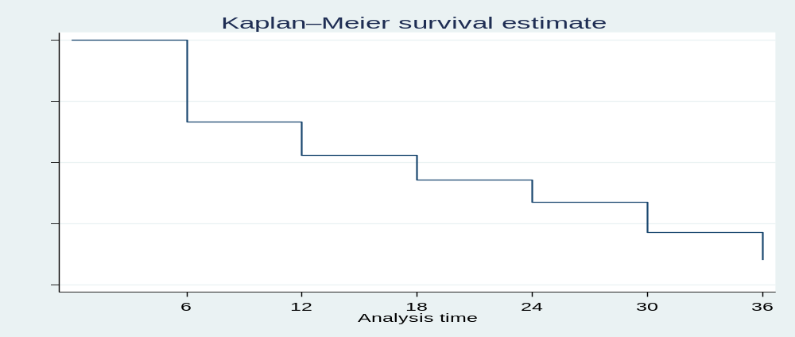

The BP level at initial enrollment was significantly (P= 0.0025), higher at SBP/DBP of >=180/110 mmHg that was presented by 24% of the participants. Also, respondents with more visits represented 6% of the participants showed significance on reaching optimal BP of 140/90 mmHg. The log rank test for time to reach optimal BP is detailed on table 6 and the Kaplan Meier graphs on estimate of time to reach blood pressure targets is presented on figure 3 to 6.
Table 6: The log rank test for time to reach optimal BP of 140/90 mmHg among respondents enrolled in NCDs project.
Variable | Observed events | Expected events | Log-rank test (Chi2)
Gender
Male | 81 | 85.6 | 0.5101
Females | 342 | 337.5 | 0.5101
Age
15-39 years | 15 | 11.8 | 0.3576
40-59 years | 178 | 167.8 | 0.3576
60-79 years | 213 | 224.8 | 0.3576
80+ years | 17 | 18.6 | 0.3576
Occupation
Peasant | 130 | 119.4 | 0.169
Others | 292 | 302.7 | 0.169
Distance
Distance 0-19 km | 134 | 113.5 | 0.0242
Distance 20-39 km | 109 | 106.3 | 0.0242
Distance 40-59 km | 82 | 87.5 | 0.0242
Distance 60-79 km | 61 | 77.9 | 0.0242
Distance 80+ km | 21 | 21.8 | 0.0242
Health insurance
no NHIF | 299 | 321.2 | 0.0026
NHIF | 124 | 101.8 | 0.0026
Number of visits
0-3 HC Visits | 82 | 141.9 | 0.000
4-8 HC Visits | 317 | 253.4 | 0.000
9+ HC Visits | 24 | 27.7 | 0.000
Life style
Healthy lifestyle | 198 | 199.3 | 0.8777
Unhealthy lifestyle | 225 | 223.7 | 0.8777
BMI
Under weight (BMI<18 kg/m²) | 4 | 9.3 | 0.1389
Healthy weight (BMI-18-24 kg/m²) | 139 | 144.0 | 0.1389
Over weight (BMI-25-29 kg/m²) | 136 | 134.9 | 0.1389
Obese (BMI >=30 kg/m²) | 137 | 127.8 | 0.1389
Status of HTN
Already known HTN | 286 | 289.0 | 0.7084
HTN new diagnosis | 137 | 134.0 | 0.7084
Blood Pressure
Grade I BP < 160/100 mmHg | 160 | 136.3 | 0.0028
Grade II BP < 180/110 mmHg | 163 | 164.1 | 0.0028
Grade III BP >=180/110 mmHg | 100 | 122.5 | 0.0028
Diagnosis
Only Hypertension | 355 | 352.9 | 0.7452
Hypertension and Diabetes Mellitus | 68 | 70.1 | 0.7452
Complications
No complications | 313 | 300.2 | 0.1013
Complications | 110 | 122.8 | 0.1013

Figure 3: Kaplan-Meier graph of survival estimate with target blood pressure based on health insurance
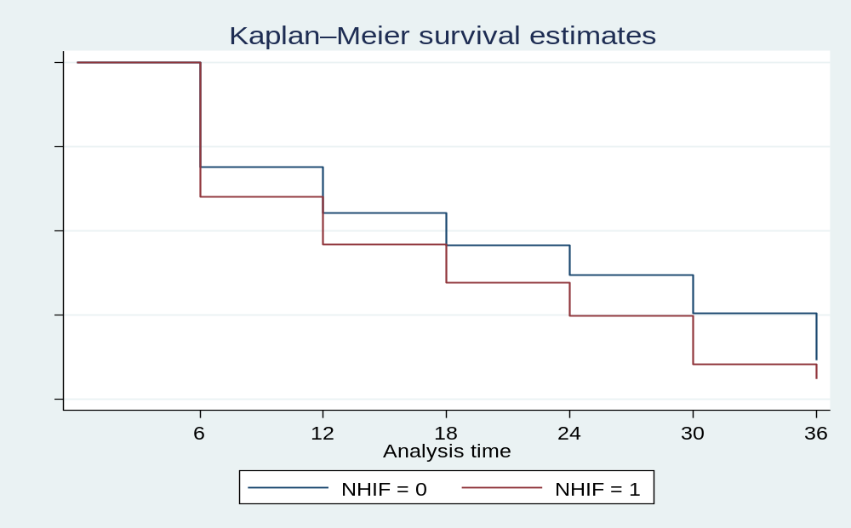

Figure 4: Kaplan-Meier graph of survival estimate with target blood pressure-based distance from District Hospital
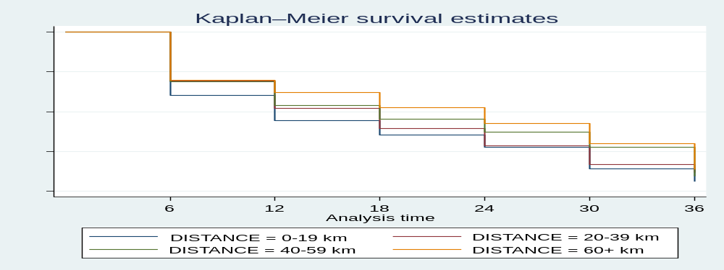

Figure 5: Kaplan-Meier graph of survival estimate with target blood pressure-based number of follow up visits
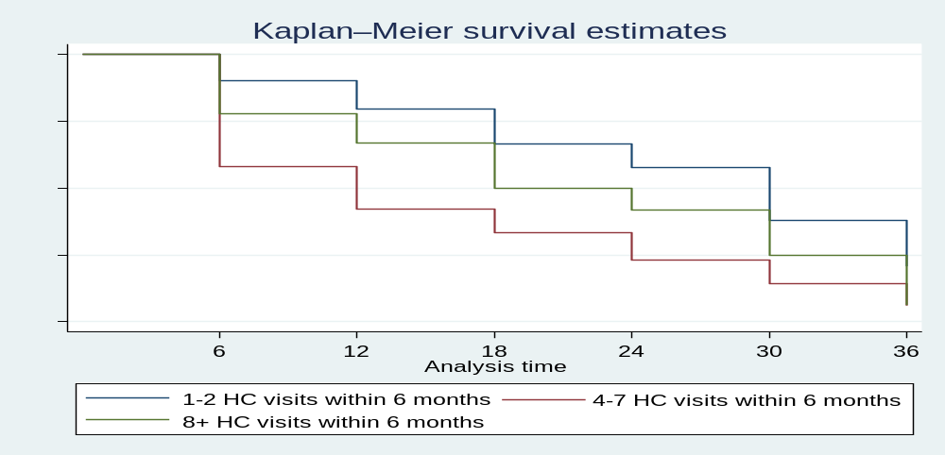

Figure 6: Kaplan-Meier graph of survival estimate with target blood pressure-based Blood pressure level at initial assessment
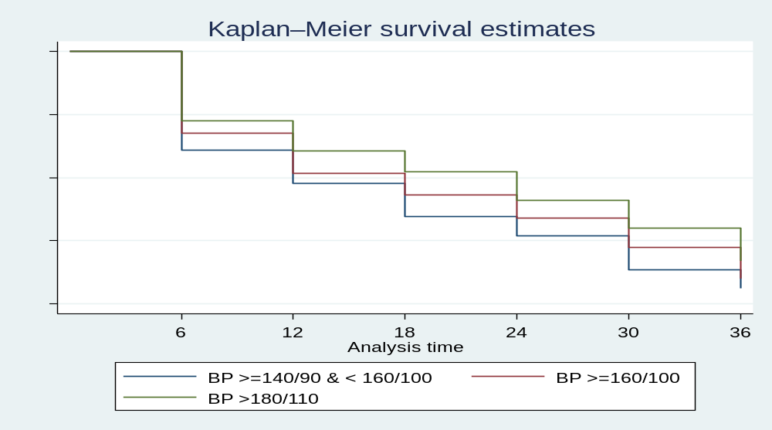

Figure 7: Kaplan-Meier graph of survival estimate with target blood pressure based on complications

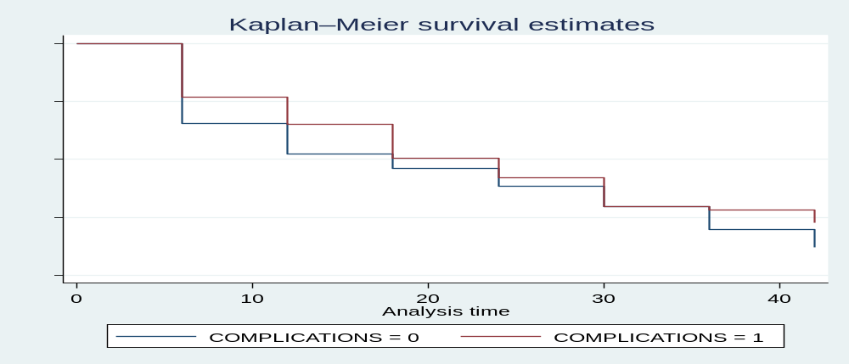

Factors that influence time to event of reaching optimal blood pressure of 140/90 mmHg among respondents enrolled in NCDs project in rural Iringa

The cox-regression of multivariate analysis for time to reach optimal blood pressure revealed that those living near the district hospital showed better results to attain optimal blood pressure compared from those living in peripheral health centers (HR=1.26, 1.02-1.57 CI 95%). Additionally, participants with high blood pressure of BP >=180/110 mmHg on their initial assessment were less significant to reach optimal blood pressure (HR=0.67, 0.52-0.86 CI 95%). This could be due to the fact that they have developed other complications such as kidney failure, heart failure which complicated their treatments. The cox-regression of multivariate analysis for time to reach blood pressure target is detailed on Table 7.

Table 7: Cox-regression multivariate analysis for time to reach blood pressure target of 140/90 mmHg
Variable | Hazard ratio (OR) | Hazard ration 95% CI | P-value
Gender
Male | 1.00 | 1
Females | 1.13 | 1.13 (0.88 -1.47) | 0.339
Age
15-39 years | 1.00 | 1
40-59 years | 0.70 | 0.7 (0.41-1.21) | 0.198
60-79 years | 0.65 | 0.65 (0.38-.13) | 0.126
80+ years | 0.60 | 0.60 (0.29- 0.25) | 0.174
Occupation
Others | 1.00
Peasant | 0.96 | 0.9 (0.76-1.21) | 0.742
Health insurance
no NHIF | 1.00
NHIF | 1.21 | 1.21 (0.95-1.53) | 0.120
Health facility
Peripheral Health Centre | 1.00
District hospital | 1.26 | 1.26 (1.02-1.57) | 0.034
Number of visits
0-3 HC Visits | 0.42 | 0.42(0.32-0.54) | 0.000
4-8 HC Visits | 1.00
9+ HC Visits | 0.67 | 0.67(0.44-1.03) | 0.069
Life style
Healthy lifestyle | 1.00
Unhealthy lifestyle | 1.04 | 1.04 (0.85-1.27) | 0.722
BMI
Under weight (BMI<18 kg/m²) | 0.44 | 0.4 (0.16-1.19) | 0.105
Health weight (BMI 18-24 kg/m²) | 1.00
Over weight ( BMI 25-29 kg/m²) | 1.03 | 1.03 (0.80-1.33) | 0.793
Obese (BMI >=30 kg/m²) | 1.04 | 0.81-1.34 | 0.767
Status of HTN
Already known HTN | 1.00
HTN new diagnosis | 1.11 | 1.1. (0.89-1.37) | 0.359
Blood pressure
Grade I (BP < 160/100 mmHg) | 1.00
Grade II (BP < 180/110 mmHg) | 0.81 | 0.8(0.65-1.02) | 0.068
Grade III (BP >=180/110 mmHg) | 0.67 | 0.67 (0.52-0.86) | 0.002
Diagnosis
Only Hypertension | 1.00
Hypertension and Diabetes Mellitus | 0.89 | 0.89 (0.68-1.16) | 0.380
Complications
No complications | 1.00
Complications | 0.90 | 0.72-1.12 | 0.345

CHAPTER FIVE

DISCUSSION

Discussion
This study aimed on assessing predictors of survival among hypertensive patients attending NCDs clinics in Iringa rural areas. The results show that patients with a severe form of disease at enrollment, in this case, those who were on a hypertensive crisis with severely high blood pressure, were less likely to be compliant in the treatment regimen than others. This could be due to the fact that they have developed other complications such as kidney failure, heart failure which complicated their treatments. Living closer to the district hospital enhanced compliance to clinical visits. Only a third of the returning patients in care, attained the optimum blood pressure control at 140/90mmHg. The loss of follow-up among patients dropped with time to reach 19% of the total patients enrolled from the beginning.

Baseline characteristics of hypertensive patients attending NCDs clinic in rural Iringa.
More than half of the participants were practicing unhealthy life style and alcohol was the most practice followed by sedentary life style and smoking. Also, one third of participants were obese at their baseline enrollment. The similar findings were found in Algeria were unhealthy life styles such as alcohol, smoking and obesity were the major risk factors for hypertensive diseases. Likewise, in India physical activity, salt intake, smoking and alcohol consumption was correlated with hypertension. This entails that primary prevention on NCDs such as awareness campaign and life style modifications should be stressed in rural areas. (40,41)
Moreover, number of hypertensive participants on follow visits for continuum care after every six months were gradually decreasing during three years of follow up time. This finding differs with the follow up management services and health outcomes of Hypertension in China where many hypertensive patients received their follow up care which were provided at hospital, home and community health centers and the large proportional received their care at medical facilities than house hold visits. Perhaps, this was based on various challenges such as distance from health facility, lack of health insurance, and availability of drugs. To address these social determinants pre-appointment remainders should be done and NCDs services should be extended close to their home such dispensaries and health centers (42).

The rate of time to reach optimal blood pressure among hypertensive patients attending NCDs clinic in rural Iringa.
The prevalence of hypertension among participants were more than fifty percent which was higher than participants with other diagnosis and female were mostly affected than male. The study done in Namibia and Iran found the similar prevalence between men and female. The high prevalence of hypertension in rural areas reflect the true picture of disease burden in rural areas which show the necessity of NCDs care services in rural areas where NCDs services are less prioritized. (37–39).
The number of participants who reached optimal blood pressure was high on the first six months compared with following months. The study revealed that meeting optimal blood pressure has less association with number of follow up visits. This could be attributed by other factors such as drug resistance, poor adherence of drugs, and disease pathology. Furthermore, blood pressure level and complications at initial enrollment were found to be associated with survival with optimal blood pressure. The study conducted in China found that participants who had regular follow up management services met optimal blood pressure. Besides that, the average reduction in blood pressure were associated with adherence on medication, health behaviors such as salt intake, physical activities that improved gradually based on the practice of the patient and readiness for adherence. (42).
In addition, age and gender were not found to be associated with survival with optimal blood pressure. This result agrees with previous study done in Tanzania which found that women showed a significantly higher prevalence of obesity but a lower risk of hypertension. Conversely, the similar study done in China found that age, sex, as well as marital status were associated with reaching the optimal blood pressure. This difference can be associated with gender-based influences in the continuation of long-term care for chronic illness where men in rural areas usually attend treatments when they had severe signs and symptoms of an illness or were in the severe stage of disease. (42,43)

Factors that influence reaching optimal blood pressure among hypertensive patients attending NCDs clinic in rural Iringa.
People living in rural areas face challenges in accessing health services which have great contributions on their survival with optimal blood pressure control. The participants living close with the district hospital were able to survival with optimal blood pressure control due various reasons such as less travelling costs and easy accessibility of the care, which enables adherence on their treatments. This finding agrees with the study which found that participants living in urban areas were more likely to have controlled blood pressure compared with participants on rural areas. In the same vein, drug adherence as well as presence of other comorbidities were discovered to have the influence on reaching the target blood pressure.(42)
Almost two third of patients with high blood pressure have no health insurances. This entails that majority were developing complications due to lack of access on treatments and medications. This result aligns with study previously conducted in Tanzania where health insurance was found to be associated with access on medical care and treatment but not associated with blood pressure control and awareness. However, the previous study done in the NCDs project where this study was carried out revealed that health insurance was the significant tool for best outcomes among patients enrolled in the project. Also, it highlighted the gender-based influence on continuum care where females were more commitment on treatments than male. In this regards, health services for NCDs should be prioritized in rural areas through health insurances which can enable accessibility of NCDs services among patients curbed with chronic diseases in rural areas to protect them against complications. (24,39)
Moreover, participants who had blood pressure greater than 180 were found to have a less chance of meeting the target blood pressure. This could be due to the fact that they have developed other complications such as kidney failure, heart failure which complicated their treatments. However, the status should be supported with various factors such as distance from the health center as well as health insurance to cover the treatment costs.(44)

Cardiovascular Nursing Implications.
The study findings show that specialized nurses, such as cardiovascular nurses, may be multi-functional in providing the continuum of care within communities given their expanded role and competence. It can serve as an important follow-up and monitoring point of care given that distance to health facilities is a problem. This is an area where holistic care and patient advocacy to enhance compliance to healthy behavioral changes in life style can be affected. Extending primary prevention services such as awareness campaign, massive screening in peripheral areas. Furthermore, nurses should be open minded on gender-based influence for continuum care among NCDs patients where males show less on their treatments compared to women. To address this social determinant, they should create a pre-appointment remainder as well as close follow up visits.

Strengths and limitation of the study

Strengths
To my understanding this is the first Clinical Nursing study that has looked on predictors of survival among hypertensive patients in a rural area of Tanzania. The study used both Kaplan Meier test for bivalent analysis to identify the association of various factors between comparable groups for survival with target blood pressure. Furthermore, the study utilized cox regression for multivalent analysis for assessing the influence to reach target blood pressure. This analysis provides accurate understanding of true association between dependent and independent variables of interest.

Limitation
The study used the data from the project data base where some data were missing which was censored and excluded from the study. More importantly, data on mortality which made lack of significant evidence on outweighing the outcome of participants with targeted blood pressure as well as assessment of predictors of mortality among participants. In addition, the complications were lumped together without delineation for the mere reasons that those who had complications, were referred out of the area to the regional hospital. The available data only indicated complication. There is also a number of patients that we recorded as loss to follow-up and censored, but some of these patients were those who were referred. This also underscores the essence of clinical data to be recorded with completeness. Furthermore, Iringa district has ten health centers and two hospitals. The study used data from nine health centers and one hospital which is district Hospital, data from one health center and one hospital was missing because they were not enrolled in the project.

CHAPTER SIX

CONCLUSION AND RECOMMENDATIONS

Conclusion
This study examined the three-year predictors of survival among hypertension patients who visited outpatient clinics in rural regions of the Iringa region. This study discovered that health insurance, number of follow-up visits, distance from district hospital, and baseline blood pressure level at enrollment were all predictors of survival with target blood pressure. However, BMI, lifestyle, age, hypertension diagnosis, and known hypertensive status were not linked with survival with target blood pressure among hypertensive patients.
These study findings highlight the need for the health care system to improve access to quality health care services for NCDs in rural areas, such as expanding NCD clinic services into nearby health centers and increasing the number of trained skilled health professionals who can address NCD challenges and complications in rural areas. Furthermore, health insurances should be made available, allowing hypertensive people living in rural areas to cover health care treatments. This will improve medication adherence, make medications and therapies more accessible for continuum care, and reduce the number of hypertensive patients who experience consequences from uncontrolled hypertension. Furthermore, primary prevention through awareness campaigns and health promotion on healthy lifestyles such as exercise, salt limits, and unsaturated fats should be implemented in rural regions to raise knowledge of hypertension disease. This would eventually reduce the frequency of hypertension disorders by early detection and treatment.

Recommendations
Based on research findings the following are recommended;
- Health care providers should provide pre-appointment reminders to patients about their monthly follow-up visits, which will reduce the number of lost follow-ups.
- Primary prevention services and health promotion on NCDs should be conducted in rural areas for early detection of hypertensive cases and increase awareness of hypertension disease for continuum care.
- Government should strengthen NCDs services in rural areas through expansion of NCDs services in dispensaries and community which will enable hypertensive patients to access services close to their home and reduce the burden of walking for long distance to follow their treatments.
- Policy makers: Should ensure access of health insurance among patients living in rural areas and if possible free services for patients with chronic diseases such as Diabetes and hypertension. This will rise adherence on medications as well as accessibility of drugs and treatments for continuum care and reduction on the number hypertensive patients developing complications following uncontrolled hypertension.
- Further comparable study is need to assess the predictors of survival and mortality with hypertension among hypertensive between patients living in urban and rural areas. This will give an insight on the commonalities and differences based on their practices.

REFERENCES
1. WHO. Hypertension [Internet]. 2022. [cited 2023 May 13]. Available from: https://www.who.int/news-room/fact-sheets/detail/hypertension#:~:text=Hypertension (high blood pressure) is,get your blood pressure checked.
2. Cambridge Dictionary. Predictor [Internet]. 2023 [cited 2023 Dec 16]. Available from: https://dictionary.cambridge.org/dictionary/english/predictor#:~:text=predictor in English-,predictor,socioeconomic status of the parents.
3. CDC. Epidemiology Glossary [Internet]. 2023 [cited 2023 Dec 16]. Available from: https://www.cdc.gov/reproductivehealth/data_stats/glossary.html
4. Cochrane Library. Survival rate [Internet]. [cited 2023 Dec 16]. Available from: https://www.cochranelibrary.com/advanced-search/mesh
5. Clark TG, Bradburn MJ, Love SB, Altman DG. Survival Analysis Part I: Basic concepts and first analyses. Br J Cancer. 2003;89(2):232–8.
6. Lee LT, Bowen PG, Mosley MK, Turner CC, Wilson, M.S. , Metink-Kane MM. Incidence and Prognosis of Resistant Hypertension in Hypertensive Patients. Bone [Internet]. 2017;23(1):1–7. Available from: https://www.ncbi.nlm.nih.gov/pmc/articles/PMC3624763/pdf/nihms412728.pdf%0Ahttp://dx.doi.org/10.1016/j.nurpra.2016.07.013
7. Bilić J, Skokandić L, Puljak L. Anticipatory grief and experience of providing at-home palliative care among informal caregivers of spouses in Croatia: a qualitative study. BMC Palliat Care [Internet]. 2022;21(1):1–16. Available from: https://doi.org/10.1186/s12904-022-01093-1
8. Adeloye D, Basquill C. Estimating the prevalence and awareness rates of Hypertension in Africa: A systematic analysis. PLoS One. 2014;9(8).
9. Mosha NR, Mahande M, Juma A, Mboya I, Urassa M, Michael D, et al. Prevalence , awareness and factors associated with Hypertension in North West Tanzania. Glob Health Action [Internet]. 2017;10(1). Available from: https://doi.org/10.1080/16549716.2017.1321279
10. Ataklte F, Erqou S, Kaptoge S, Taye B, Echouffo-Tcheugui JB, Kengne AP. Burden of undiagnosed Hypertension in sub-saharan africa: A systematic review and meta-analysis. Hypertension. 2015;65(2):291–8.
11. Okello S, Muhihi A, Mohamed SF, Ameh S, Ochimana C, Oluwasanu AO, et al. Hypertension prevalence, awareness, treatment, and control and predicted 10-year CVD risk: a cross-sectional study of seven communities in East and West Africa (SevenCEWA). BMC Public Health. 2020;20(1):1–13.
12. Labata BG, Ahmed MB, Mekonen GF, Daba FB. Prevalence and predictors of self care practices among hypertensive patients at Jimma University Specialized Hospital, Southwest Ethiopia: Cross-sectional study. BMC Res Notes [Internet]. 2019;12(1):1–8. Available from: https://doi.org/10.1186/s13104-019-4125-3
13. Psara E, Pentieva K, Ward M, Mcnulty H. Biochimie Critical review of nutrition , blood pressure and risk of hypertension through the lifecycle : do B vitamins play a role ? Biochimie [Internet]. 2020;173:76–90. Available from: https://doi.org/10.1016/j.biochi.2020.03.016
14. Beia T, Kielmann K, Diaconu K. Changing men or changing health systems? A scoping review of interventions, services and programmes targeting men's health in sub-Saharan Africa. Int J Equity Health. 2021;20(1):1–16.
15. Polit DF, Beck CT. Nursing Research. 7th Ed. Lippincott Williams & Wilkins; 2004.
16. WHO. A Conceptual Framework for Action on the Social Determinants of Health. 2010;
17. Mills KT, Stefanescu A, He J. The global epidemiology of hypertension. Nat Rev Nephrol [Internet]. 2015;1975. Available from: http://dx.doi.org/10.1038/s41581-019-0244-2
18. Boombhi J, Lea E, Hedzo N De, Loic G, Tchoukeu N, Igor U, et al. Prevalence , complications and factors associated with severely elevated blood pressure in patients with hypertension : a cross-sectional study in two hospitals. 2022;1–10.
19. Romano S, Rigon G, Albrigi M, Tebaldi G, Sartorio A, Cristin L, et al. Hypertension , uncontrolled hypertension and resistant hypertension : prevalence , comorbidities and prescribed medications in 228 , 406 adults resident in urban areas . A population ‑ based observational study. Intern Emerg Med [Internet]. 2023;18(7):1951–9. Available from: https://doi.org/10.1007/s11739-023-03376-8
20. Guwatudde D, Nankya-Mutyoba J, Kalyesubula R, Laurence C, Adebamowo C, Ajayi IO, et al. The burden of hypertension in sub-Saharan Africa: A four-country cross sectional study. BMC Public Health. 2015;15(1):1–8.
21. Galson SW, Staton CA, Karia F, Kilonzo K, Lunyera J, Patel UD, et al. Epidemiology of Hypertension in Northern Tanzania: A community-based mixed-methods study. BMJ Open. 2017;7(11):1–10.
22. Isangula KG, Meda JR. The Burden of Hypertension in the Rural and Urban populations of Tanzania: A review of Trends, Impacts and Response Helping Baby Breathe (HBB) in Tanzania View project Personal behaviors, NCD risk status and patient counseling practices in Tanzania View p. Tanzania J Heal Sci [Internet]. 2017;1(1):42–52. Available from: https://www.researchgate.net/publication/322930919
23. Ploth DW, Mbwambo JK, Fonner VA, Horowitz B, Zager P, Schrader R, et al. Prevalence of CKD, Diabetes, and Hypertension in Rural Tanzania. Kidney Int Reports [Internet]. 2018;3(4):905–15. Available from: https://doi.org/10.1016/j.ekir.2018.04.006
24. Miselli MA, Cavallin F, Marwa S, Ndunguru B, Itambu RJ, Mutalemwa K, et al. An Integrated Management System for Non-communicable Diseases Program Implementation in a Sub-Saharan Setting. 2021;
25. Reddy KS, Katan MB. Diet, nutrition and the prevention of hypertension and cardiovascular diseases. Public Health Nutr. 2004;7(1a):167–86.
26. Nardocci M, Polsky JY, Moubarac JC. Consumption of ultra-processed foods is associated with obesity, Diabetes and Hypertension in Canadian adults. Can J Public Heal. 2021 Jun 1;112(3):421–9.
27. Barbosa SS, Sousa LCM, de Oliveira Silva DF, Pimentel JB, Evangelista KCM de S, Lyra C de O, et al. A Systematic Review on Processed/Ultra-Processed Foods and Arterial Hypertension in Adults and Older People. Vol. 14, Nutrients. MDPI; 2022.
28. Gonde LL, Chimbari MJ. Community awareness of diet needs associated with hypertension and type 2 diabetes mellitus in Hatcliffe, Zimbabwe. BMC Public Health. 2019 Dec 16;19(1).
29. Abdalla AA. Knowledge, attitude and practice towards therapeutic lifestyle changes in the management of Hypertension in Khartoum State. Cardiovasc J Afr. 2021 Jul 1;32(4):198–203.
30. Tadesse DB, Gerensea H. Self-care practice among hypertensive patients in Ethiopia: Systematic review and meta-analysis. Vol. 8, Open Heart. BMJ Publishing Group; 2021.
31. Ministry of Health and Social Welfare. National Non-communicable Diseases Strategy. Minist Heal Soc Welf. 2015;(June):1–16.
32. Tanzania MoHCDGEC. Strategic and action plan for the Prevention and control of non communicable diseases in Tanzania 2016 - 2020. 2016;128. Available from: https://www.worlddiabetesfoundation.org/sites/default/files/NCD Stategic Plan 2016 - 2020.pdf
33. Chakraborty S, Rai RK, Biswas AK, Barik A, Gurung P, Praveen D. Health care seeking behaviour and financial protection of patients with Hypertension: A cross-sectional study in rural West Bengal, India. PLoS One [Internet]. 2022;17(2 February):1–16. Available from: http://dx.doi.org/10.1371/journal.pone.0264314
34. Musinguzi G, Anthierens S, Nuwaha F, Van Geertruyden JP, Wanyenze RK, Bastiaens H. Factors Influencing Compliance and Health Seeking Behaviour for Hypertension in Mukono and Buikwe in Uganda: A Qualitative Study. Int J Hypertens. 2018;2018.
35. Hertz JT, Sakita FM, Kweka GL, Loring Z, Thielman NM, Temu G, et al. Healthcare-seeking behaviour, barriers to care and predictors of symptom improvement among patients with cardiovascular disease in northern Tanzania. Int Health. 2022;14(4):373–80.
36. National burea of statistics. Tanzania census 2022 results [Internet]. 2022. [cited 2023 Jun 3]. Available from: https://sensa.nbs.go.tz/
37. Mirzaei M, Mirzaei M, Bagheri B. Awareness , treatment , and control of hypertension and related factors in adult Iranian population. 2020;1–10.
38. Craig LS, Gage AJ, Thomas AM. Prevalence and predictors of Hypertension in Namibia: A national-level cross-sectional study. PLoS One. 2018;13(9):1–14.
39. Osetinsky B, Mhalu G, Mtenga S, Tediosi F. Care cascades for hypertension and Diabetes: Cross-sectional evaluation of rural districts in Tanzania. PLoS Med [Internet]. 2022;19(12):1–17. Available from: http://dx.doi.org/10.1371/journal.pmed.1004140
40. Thanglen H, Maheo LM. Prevalence of obesity and Hypertension and its associated risk factors among chiru females of Manipur. Indian J Public Health. 2022;66(1):3–8.
41. Moussouni A, Sidi-yakhlef A, Hamdaoui H, Aouar A, Belkhatir D. Prevalence and risk factors of prehypertension and Hypertension in Algeria. BMC Public Health [Internet]. 2022;22(1):1–17. Available from: https://doi.org/10.1186/s12889-022-13942-y
42. Peng M, Shi X, Zhu L, Wang Z. Follow-up management service and health outcomes of hypertensive patients in China: A cross-sectional analysis from the national health service survey in Jiangsu province. Front Public Heal. 2022;10.
43. Njelekela MA, Mpembeni R, Muhihi A, Mligiliche NL, Spiegelman D, Hertzmark E, et al. Gender-related differences in the prevalence of cardiovascular disease risk factors and their correlates in urban Tanzania. BMC Cardiovasc Disord. 2009;9:1–8.
44. Migora B. Survival Time to Development of Hypertension and Its Predictors among a Cohort of Diabetic Patients in Health Facilities of Gurage Zone : A Retrospective Follow-Up Study. 2021;(May):259–66.

APPENDICES


APPENDIX I: DATA COLLECTION TOOLS

The following laboratory investigations are to be performed FOR FREE,
UNLESS the patient has an health insurance

(HUDUMA HUTOLEWA KWA SIKU ZA JUMATATU, JUMATANO NA IJUMAA TU)
  IRINGA DISTRICT – TOSAMAGANGA D.D.H  NCDs LAB INVESTIGATIONS FORM  Iringa District  First Name: _________________________________ Last Name:__________________________________  Year of Birth: __________ Village: ______________________ Gender: ◻ M ◻ F  Telephone number: ____________________ Alternative number: _________________________ |  |  |  | 
Tosamaganga D.D.H.
BIMA ◻
◻ hypertension |  |  | ◻ Diabetes
❑ | Full Blood Picture: _________________________________________________________
❑ | Fasting Blood Glucose (if RANDOM specify):_____________________________
❑ | Creatinine: _________________________________________________________________
❑ | HbA1c (ONLY for diabetic patients): _____________________________________
❑ | Total cholesterol: __________________________________________________________
❑ | Urine Protein: ______________________________________________________________
❑ | Urine Ketons: ______________________________________________________________
Other notifications:
_________________________________________________________________________________________________ _
_______________________________________________________________________________________________
To be performed on ________Dr. _____________________

IRINGA DISTRICT – TOSAMAGANGA D.D.H
NCDs CLINICAL RECORD
Iringa District - TREATMENT CARD Tosamaganga D.D.H.
First Name: _________________________________ Last Name:__________________________________
Hospital Number: _________________________ Health Center: ______________________________
Year of Birth: _____________ Village: _________________________________ Gender: ◻ M ◻ F Telephone number: _______________________ Profession: _________________________________
◻ BIMA ◻ OTHER EXEMPTIONS
BP at referral: ____________________ mmHg  - NEW DIAGNOSIS  - YEAR OF DIAGNOSIS: ______________  HTN treatment: _____________________  ____________________________________ | FBG/RBG at referral: __________ mmol/L  - NEW DIAGNOSIS  - YEAR OF DIAGNOSIS: ______________  Diabetes treatment: ________________  ___________________________________
◻ hypertension  Date of registration: _____________________ | ◻ Type 2 diabetes ◻ Type 1 diabetes  Date of registration: _____________________

Clinical history
  - Family history of H.T.N. / ◻ Diabetes  - Alcohol abuse  - Smoking  - Sedentary lifestyle  - Prior ischaemic heart disease  - Chronic heart failure | - Prior stroke  - Chronic kidney failure  - Vision impairment  - Peripheral neuropathy  - Peripheral arterial disease  - _____________________________________
Height: _________________cm Weight: _________________Kg BMI: ___________________Kg/m²
Lifestyle modification:
◻ Lifestyle modification alone ◻ Lifestyle modification and medication
Other notifications:
_________________________________________________________________________________________________
_________________________________________________________________________________________________
_________________________________________________________________________________________________
_________________________________________________________________________________________________
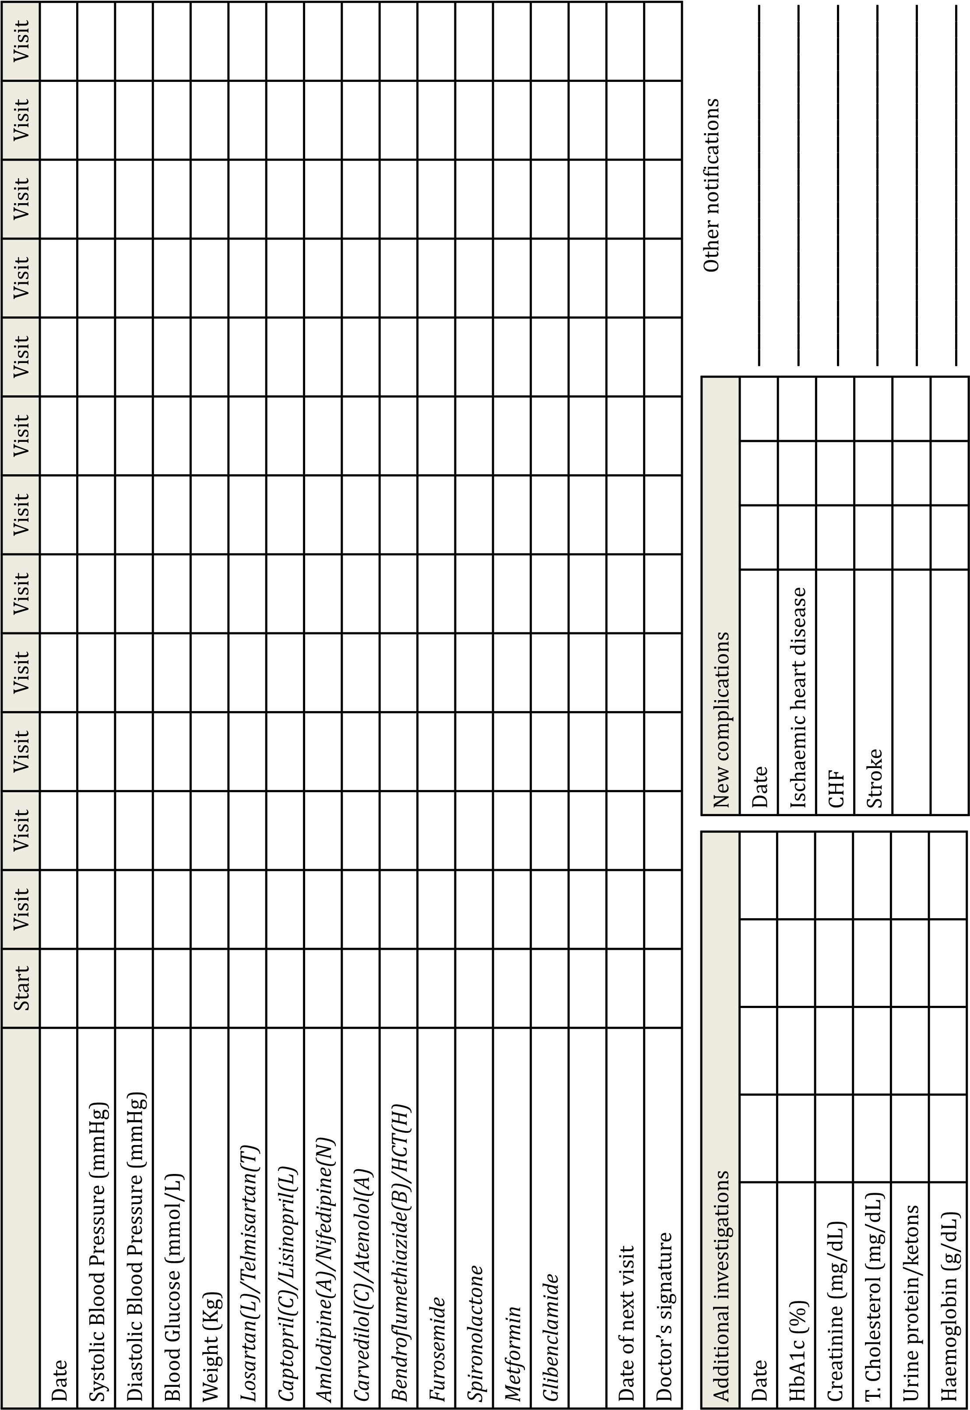

APPENDIX II: ETHICAL CLEARANCE APPROVAL

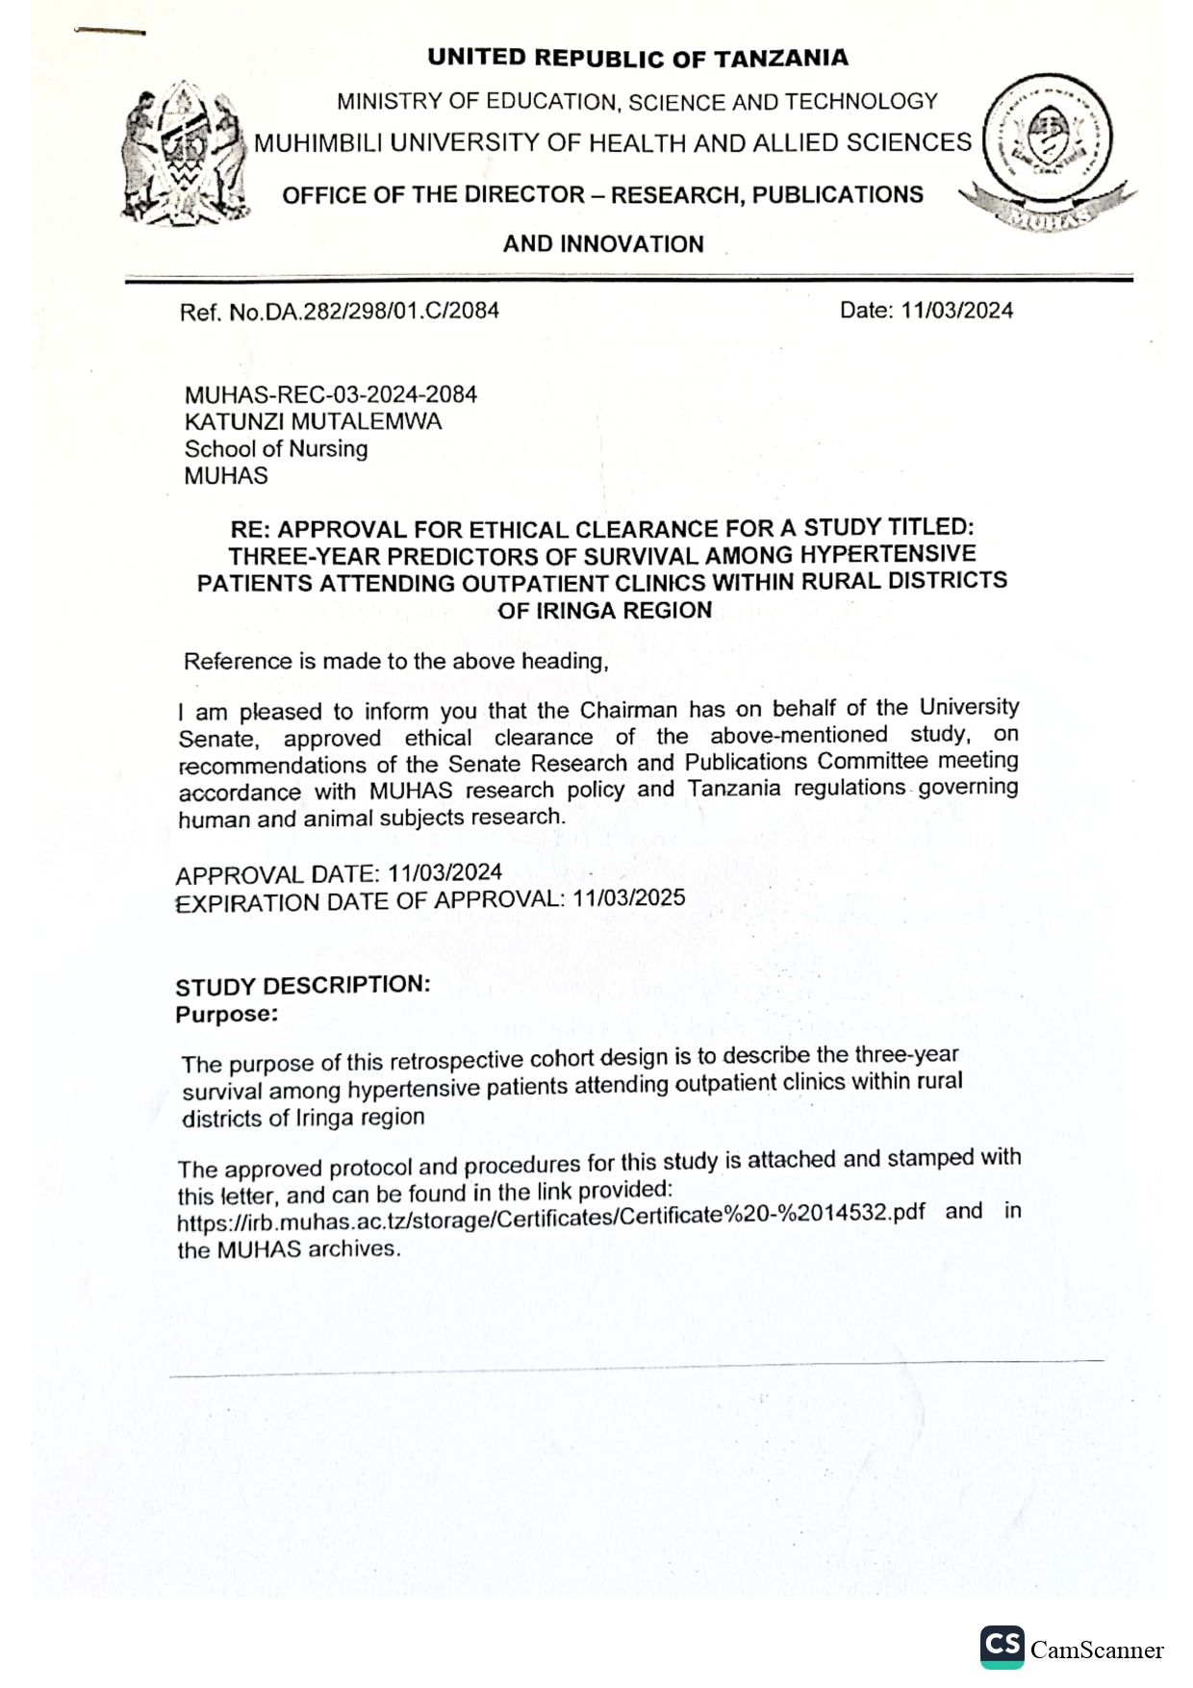

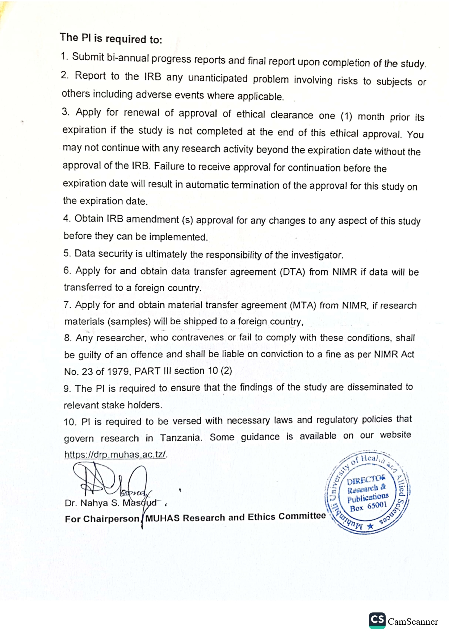

APPENDIX III: INTRODUCTION LETTER


APPENDIX IV: PERMISSION LETTER
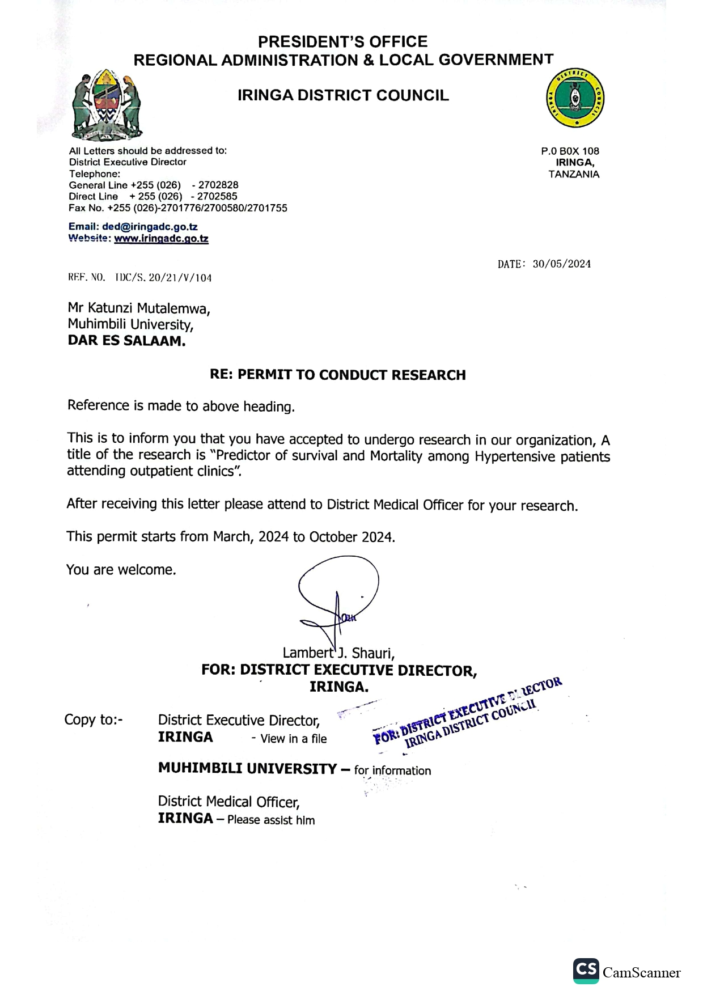

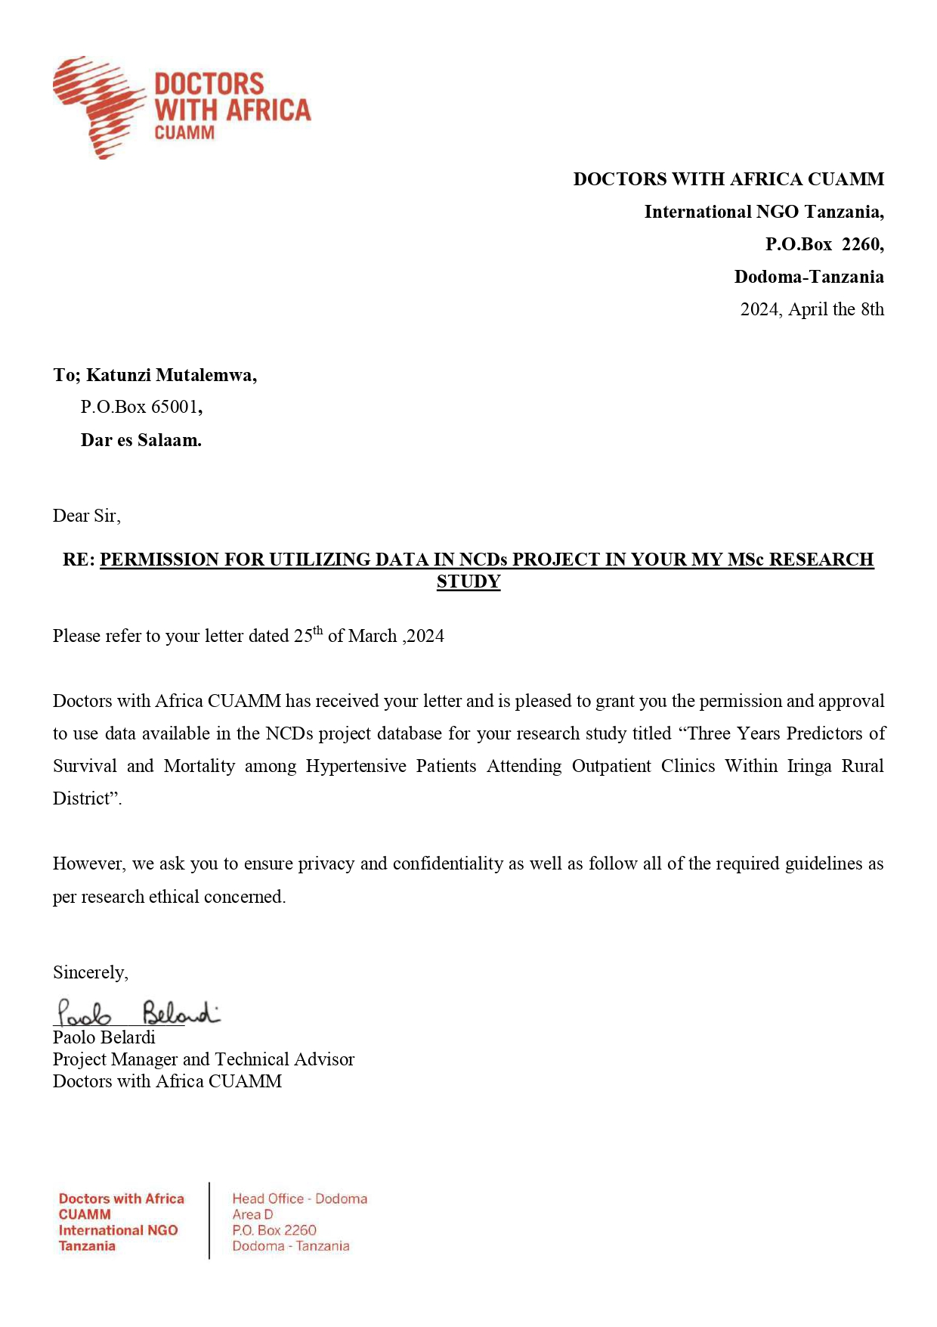

APPENDIX V: PLAGIARISM CERTIFICATES
